Green Schools News |   This Photo by Unknown Author is licensed under CC BY-NC
We are delighted to announce that our Green School’s committee is now up and running in the senior room and we are excited to work on our 4th Green Schools Theme – Travel.

Over the next two years we will be working closely with the Green Schools Travel Team to promote awareness of the importance of sustainable travel. We will be considering the risks that poor air quality poses to children and the most vulnerable in society and encouraging our school community to take action to reduce air pollution through considering active travel for shorter journeys (walking, cycling, scooting) where possible as an alternative to always taking the car.

Our work on the theme began with a workshop with the Green Schools Travel Officer and the committee have also taken part in traffic and speed surveys at our school. It was noted by the Travel Officer that due to our school’s rural setting and its position on the junction of two busy roads, it may not be possible for many of our pupils to use alternative travel methods to get to school. Furthermore, currently, due to the Covid situation, car-pooling is also not advisable, however this may be something which we will try to promote at a later stage, should circumstances change.

During the month of February the Green Schools promote a Big Travel Challenge. We would like to ask everyone to think twice before making a car journey, think first is this trip really necessary? and could I cycle or walk instead?

Did You Know??
In Ireland over the last 30 years increase in travel by private car has resulted in…

- A decrease in daily physical activity and an increase in health issues.  - An increase in transport pollution, including green house gas emissions. | 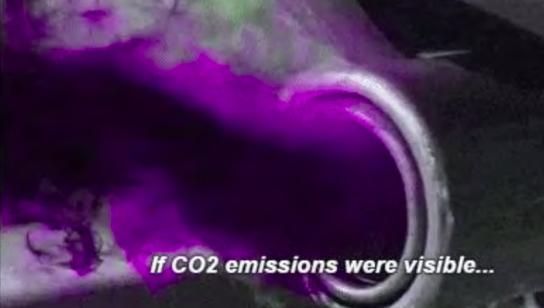
- An increase in illness and deaths associated with traffic pollution
- An increase in traffic congestion.
- A reduction in safety for pedestrians and cyclists
- Delayed development of life skills such as personal safety, independence and road safety.
- Transport accounts for 19.8% of Ireland’s Greenhouse gases.
- Ireland’s greenhouse gas emissions per person are amongst the highest in the world, in 2015 we were the third highest in the E.U.

Benefits of Active Travel – Leaving the car at home
Environmental benefits  - Improved air quality  - Less traffic on the roads  - Reduced Noise pollution  - Reduces our Carbon Footprint  - Supports Biodiversity in our area  - Helps us connect with nature | 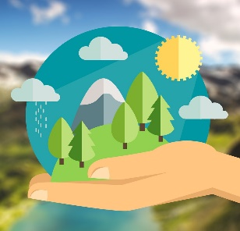  This Photo by Unknown Author is licensed under CC BY-SA
Health Benefits  - Exercise maintains and increases fitness levels  - It builds stronger bodies and stronger bones  - Weight management  - Promotes healthy hearts  - Promotes healthy minds:- being active releases endorphins which make us feel good, alleviating worries and anxieties.  - Social well-being, fosters independence and builds relationships | 
Take part in the Big travel Challenge for February and leave the car at home!
