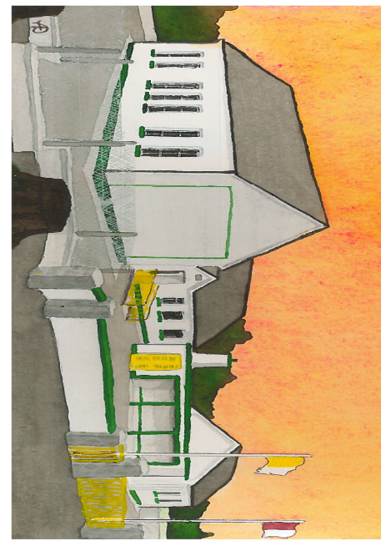
Kilglass NS,
Kilglass,
Ahascragh,
Ballinasloe,
Co. Galway.
31-09-21

0909688881
kilglass@hotmail.com

Dear Parents/Guardians,
As we return to another school year we extend a very warm welcome return to our students and their families. Best wishes to our New Junior Infant class, we hope you will enjoy your time with us over the coming years. This year we have 118 students in our school and with the support and co-operation of all parents and families we will strive to make the school a safe environment for our staff and students. Please ensure that the Back to School form is returned before school starts (this can be done through the link sent through textaparent). Please familiarise yourself and your child with the Return to School Plan and Pick Up/Collection Times which can be found on www.kilglassns.com/news/ (if you require a hard copy of any of this information please contact the school at 0909688881). Also, I wish to bring the following notices to your attention:
- Covid 19 – the school will continue with same the Covid 19 protoccols as last year, guidance on these protocols can be found on the news section of our school website www.kilglassns.com. We strongly urge parents not to send their child to school if they have any symptoms highlighted below by the HSE:
When to keep your child at home:
Do not send your child to school or childcare if any of the following apply.
Your child has:
- a temperature of 38 degrees Celsius or more
- any other common symptoms of COVID-19 - a new cough, loss or changed sense of taste or smell, shortness of breath or an existing breathing condition that has recently become worse
- been in close contact with someone who has tested positive for COVID-19
- been living with someone who is unwell and may have COVID-19
- other uncommon symptoms of COVID-19, such as sore throat or headaches
- diarrhoea
- returned from another country in the last 14 days.
- School Traffic Plan - The only areas for parking will be in the car park area beside the school field, in the interest of safety we are asking that school traffic line up on Ballygar side of the carpark and wait till a parking space becomes available, reverse into the free parking space and move on promptly once students have been collected. Please do not parallel park in front of already parked cars, the front of the school is for teacher parking only. Can parents please inform people designated to collect their children of the above traffic system, we appreciate your co-operation with this matter.

- Book Rental: we strive to keep costs as low as possible for families, the maximum that any one family will pay is €100.
4th/5th/6th:
Book rental €25
Contribution to photocoping/art resources etc €25
Digital Literacy resource: €7
Student School Insurance €8
3rd
BookRental €20
Contribution to photocoping/art resources etc €25
Digital Literacy resource: €7
Student School Insurance €8
Junior/Senior Infants/ 1st/2nd:
Book Rental €15
Contribution to photocoping/art resources etc €25
Student School Insurance €8

Money can be sent into the class teacher or through banking 365 (Insurance forms will be sent home with the oldest in each family on Sept 1st)
Account Name: Kilglass N.S
IBAN: IE28BOFI90370192574035
BIC: BOFIIE2D
Please add Family Name on Remittance.
- School Uniform: - students are to wear school uniform unless directed by the class teacher to wear sports gear on PE days, this will be communicated in the student’s homework notebook. 1st to 6th class will be playing in the field as much as possible, please ensure these students have wellies/outside shoes and spare socks each day. We will upload some samples for a new school half zip on the school website, please send any feedback to kilglass@hotmail.com.
- Attendance – as per Education Welfare Act (2000), it is mandatory for schools to report to the Education Welfare Officer all children who miss 20 days in any school year. Please send a note to the class teacher stating why a student is absent when the student returns to school. A Return to School
- Healthy Lunches – we have a Healthy Lunches policy in the school, please encourage children to bring a Healthy Lunch to school, tips on healthy lunches can be found on https://www.hse.ie/eng/services/publications/children/healthy-lunch-box-to-grow,-learn-and-play-part-1.html

- Labels – please ensure that Jumpers/Jackets etc are labelled.
- Communication: should you need to speak with myself or any other member of staff, please contact the school by phone or email on Tuesdays or Thursdays and our secretary will schedule a meeting.
- Amber Flag: this year we are hoping to receive the Well-Being/Amber Flag, details on this initiative can be found on
https://www.pieta.ie/how-we-can-help/prevention-programmes/amber-flag-initiative/
- Creative Schools: this year we have been chosen to participate in the Creative Schools Programme, further information on the project can be found on, https://www.artscouncil.ie/creative-schools/
- Contact Details – please complete the form enclosed to update any changes in contact details or changes in persons designated to collect your child and return to class teacher.
- Important dates this term:
- School Return – September 1st
- First Holy Communion – September 18th (Times to be decided)
- Mid Term – October 26th to 30th
- Christmas – December 22nd (Half Day) – return to school on January 6th.
- February Mid Term – 24th & 25th
- St Patricks Week – 17th & 18th
- Easter – April 8th (Half Day) – return to school April 25th.
- May Bank Holiday – May 2nd
- June Bank Holiday – June 3rd & 6th
- End of Year – June 28th (Half Day)
Yours Sincerely,
Vincent Glynn
Principal

Contact Details:
Name: _________________________________________
Parent 1 Mobile: ___________________ E-mail - _______________________
Parent 2 Mobile:____________________ E-mail - _______________________
Other contact: Name:__________________ Contact Number:__________________
Persons designated to collect student: ____________________
Car (type/colour/registration): _________________________________________________________________________________________________________________________________________________________________________________________________________________________________
Persons designated to collect student: ____________________
Car (type/colour/registration): ________________________________________________________________________________________________________________________________________________________________________________________________________________________________

