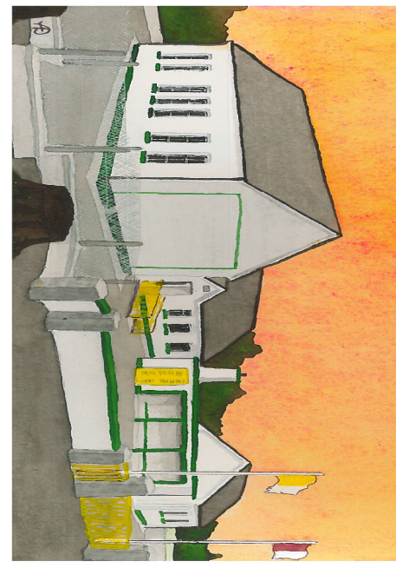
Kilglass NS,
Kilglass,
Ahascragh,
Ballinasloe,
Co. Galway.
10-3-21

0909688881
kilglass@hotmail.com
Dear Parent(s),
Next Monday will see the return to school for 4th, 5th & 6th class, given the current health advise from the HSE we still must remain extremely vigilant both in school and at home. We will have 113 students coming to and from school and we need your continued support to keep our staff, students and community safe. With this in mind it is vital that parent read our logistics plan, stick to the collection and drop off times allocated and continue to follow all HSE guidance in relation to our return to school. This information can be found on www.kilglassns.com/news. The HSE has highlighted additional areas of focus for parents over the coming weeks:
- Schools are asked to remind parents and pupils not to congregate in school grounds/at school gates.
- Please do not have play dates or organise after school activities which involve household mixing.
All 4th, 5th & 6th class students must have a Return to School formed signed before they return on Monday, the form can be found on our website (https://www.kilglassns.com/nb-return-to-school-form-parent-guidance-videos) and copies of the form will be left in the school shelter for collection after 4pm today or tomorrow. The forms can be returned on Friday along with the student’s books, pencil case etc.
Also as we settle back into our school routine we will be promoting healthy lunches as part of our return to school wellbeing programmes. There are some hints and tips on the link below: https://www.healthpromotion.ie/hp-files/docs/HAL00885.pdf
We appreciate your support on these matters.
Finally, the school will be closed on St Patrick’s Day.
Yours Sincerely,

Vincent Glynn
Principal .

