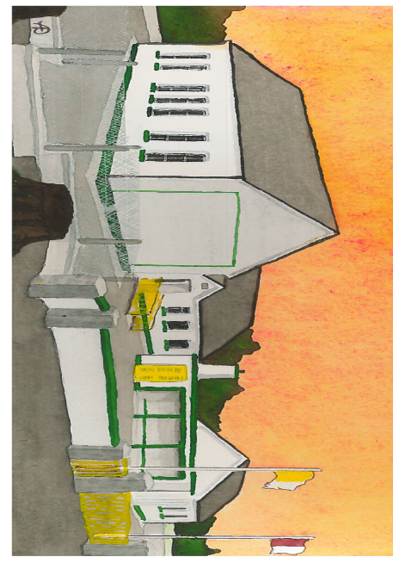
Kilglass NS,
Kilglass,
Ahascragh,
Ballinasloe,
Co. Galway.
07-12-20

0909688881
kilglass@hotmail.com
Dear Parents,
As we move towards the Festive Season I wish to bring the following notices to your attention:
- Covid 19 – we recently had a Covid 19/Health & Safety Inspection, the inspection was very positive and we will publish the report once we receive it. Our Inspector asked us to communicate with parents to continue the measures we currently have in Kilglass and make an extra effort over the coming weeks to keep our school Covid free.
- No Homework – students will have no homework for the remainder of this term.
- School Closure – the school will be closed on Thursday December 17th due to ESB maintenance in the area.
- Galway Camogie – best wishes to the Galway Camogie team this weekend, Kilglass Student Council will be holding a wear maroon day (€2 per child) on Friday 11th December, all proceeds will go towards the teams All Ireland fund.
- Christmas Plays – we will be recording our Christmas plays over the coming days, can parents send in costumes as soon as possible.
- Christmas Holidays – school will close on Tuesday December 22nd at 12 and reopen on January 7th.
- Christmas Jumper Day – we will have our annual Christmas Jumper Day on Friday December 18th, this year our chosen charity in Crumlin Children’s Hospital, further information on the charity can be found at christmasjumperday.cmrf.org.
- Christmas Cards – any children that wish to give cards to other pupils please give them to your teacher on either Friday 11th or Friday 18th and we will distribute them the following Monday in line with Covid measures.
Yours Sincerely,
Vincent Glynn

