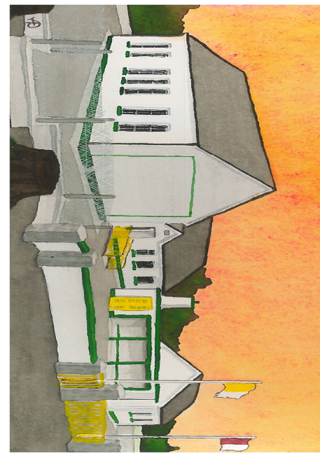
Kilglass NS,
Kilglass,
Ahascragh,
Ballinasloe,
Co. Galway.
24/08/20

0909688881
kilglass@hotmail.com
Dear Parent/Guardian,
Please complete the form below and return to school by email (kilglass@hotmail.com), leave in sealed envelope when dropping school books or post Kilglass Ns, Kilglass, Ahascragh, Ballinasloe, Co Galway. Your child cannot attend school until the form below is completed:
- Child(‘s) name:

- I/We have read and agree to the schools Code of Behaviour.

- I/We have read the Letters and Reopening the School Logistics Plan posted on school website and will adhere to the guidelines provided.

- Contact Details in case of an Emergency:

Parent(s)__________________________________________

__________________________________________________

If Parent unavailable (Name) contact: __________________

__________________________________________________

_________________________________________________

Persons designated to collect your child & their car colour, make and model to identify:

________________________________________________________________________

________________________________________________________________________

________________________________________________________________________

________________________________________________________________________

- Pre-Return to School Questionnaire COVID-19
This questionnaire must be completed in advance of returning to school.
If the answer is Yes to any of the below questions, you are advised to seek medical advice before returning to school.
Name: ________________________
Name of School: ________________________
Name of Principal: ________________________ Date: ________________
 | Questions | YES | NO
1. | Do you have symptoms of cough, fever, high temperature, sore throat, runny nose, breathlessness or flu like symptoms now or in the past 14 days?
2. | Have you been diagnosed with confirmed or suspected COVID-19 infection in the last 14 days?
3. | Have you been advised by the HSE that you are you a close contact of a person who is a confirmed or suspected case of COVID-19 in the past 14 days?
4. | Have you been advised by a doctor to self-isolate at this time?
5. | Have you been advised by a doctor to cocoon at this time?
6. | Have you been advised by your doctor that you are in the very high risk group?  If yes, please liaise with Principal re return to school and follow the agreed DES arrangements for very high risk groups

I confirm, to the best of my knowledge that I have no symptoms of COVID-19, am not self-isolating or awaiting results of a COVID-19 test and have not been advised to restrict my movements.
Please note: The school is collecting this sensitive personal data for the purposes of maintaining safety within the workplace in light of the COVID-19 pandemic. The legal basis for collecting this data is based on vital public health interests and maintaining school health and this data will be held securely in line with our GDPR policy.

Signed: ______________________________________

